Lab 13: Aggregate Functions

Part 1. Setup

Step 1. Create a schema and the tables
DROP SCHEMA IF EXISTS lab13 CASCADE;
CREATE SCHEMA lab13;
SET search_path TO lab13;
CREATE TABLE employees (
employee_id SERIAL PRIMARY KEY,
first_name VARCHAR(50),
last_name VARCHAR(50),
department VARCHAR(50),
salary INTEGER,
age INTEGER,
experience_years INTEGER,
hire_date DATE,
email VARCHAR(100),
bonus INTEGER
);
CREATE TABLE sales (
sale_id SERIAL PRIMARY KEY,
employee_id INTEGER REFERENCES employees(employee_id),
sale_date DATE,
amount INTEGER
);
CREATE TABLE products (
product_id SERIAL PRIMARY KEY,
product_name VARCHAR(50),
category VARCHAR(50),
price NUMERIC(10,2)
);

Step 2. Insert employees
INSERT INTO employees (first_name, last_name, department, salary, age, experience_years, hire_date, email, bonus) VALUES
('Aibek', 'Sharshenov', 'Engineering', 95000, 28, 5, '2021-03-15', 'aibek@gmail.com', 5000),
('Ainura', 'Toktomamatova', 'Sales', 62000, 34, 8, '2019-07-01', 'ainura@gmail.com', 3000),
('Bakyt', 'Mamatov', 'Engineering', 120000, 45, 20, '2015-01-10', 'bakyt@company.kg', 10000),
('Gulzat', 'Sultanova', 'Sales', 48000, 24, 2, '2023-05-20', NULL, NULL),
('Emir', 'Uulu', 'Marketing', 71000, 31, 6, '2020-09-01', 'emir@mail.ru', 2000),
('Meerim', 'Bekova', 'Engineering', 58000, 23, 1, '2024-02-12', 'meerim@gmail.com', NULL),
('Tilek', 'Usubaliev', 'Marketing', 105000, 52, 25, '2012-11-05', NULL, 8000),
('Nursultan', 'Isakov', 'Sales', 54000, 27, 3, '2023-08-14', 'nursultan@gmail.com', 1500),
('Aruuke', 'Bekova', 'Engineering', 87000, 38, 12, '2018-04-22', 'aruuke@company.kg', NULL),
('Kanat', 'Asanov', 'Sales', 66000, 41, 15, '2016-06-30', 'kanat@mail.ru', 2500);
SELECT * FROM employees;
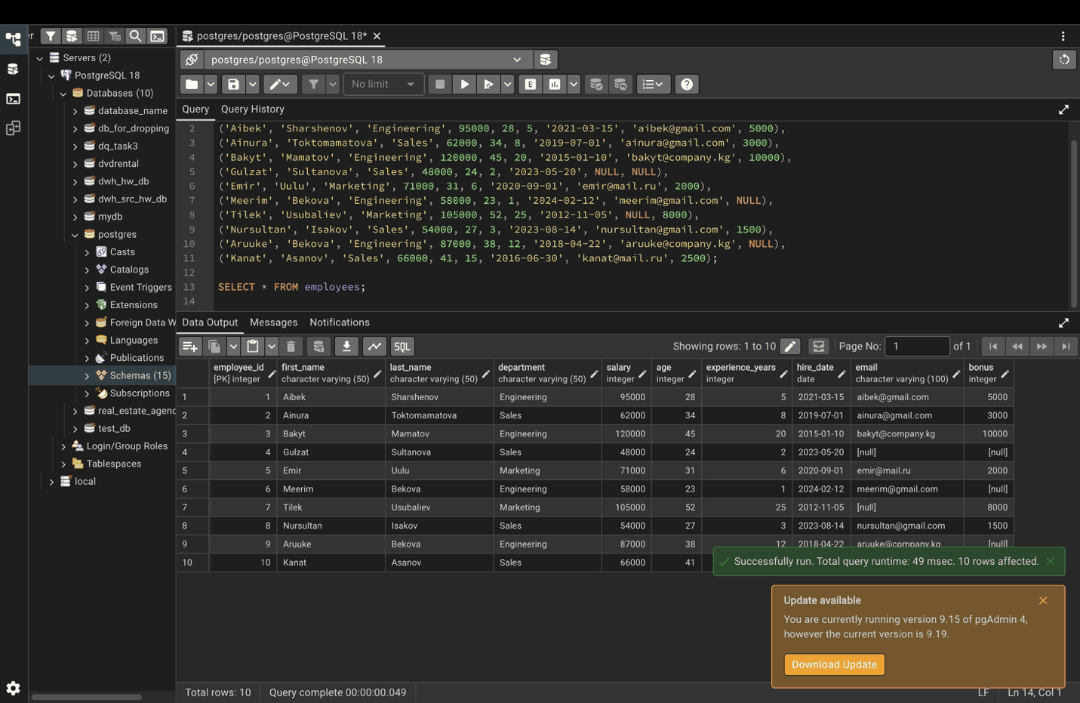

Step 3. Insert sales
INSERT INTO sales (employee_id, sale_date, amount) VALUES
(2, '2024-01-15', 1500), (2, '2024-02-20', 800), (4, '2024-04-10', 1200),
(8, '2024-05-05', 950), (10, '2024-08-18', 2200), (2, '2024-11-03', 1750),
(4, '2025-01-22', 600), (8, '2025-03-14', 1300), (10, '2025-06-09', 2500),
(2, '2025-07-25', 1100);
SELECT * FROM sales;
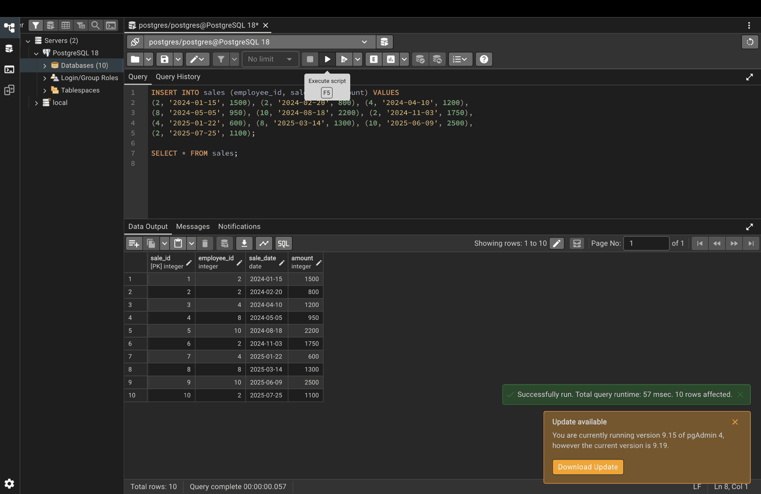

Step 4. Insert products
INSERT INTO products (product_name, category, price) VALUES
('Laptop', 'Electronics', 1200), ('Phone', 'Electronics', 800),
('Headphones', 'Electronics', 150), ('Desk', 'Furniture', 300),
('Chair', 'Furniture', 180), ('Notebook', 'Stationery', 5),
('Pen', 'Stationery', 2), ('Backpack', 'Stationery', 45);
SELECT * FROM products;
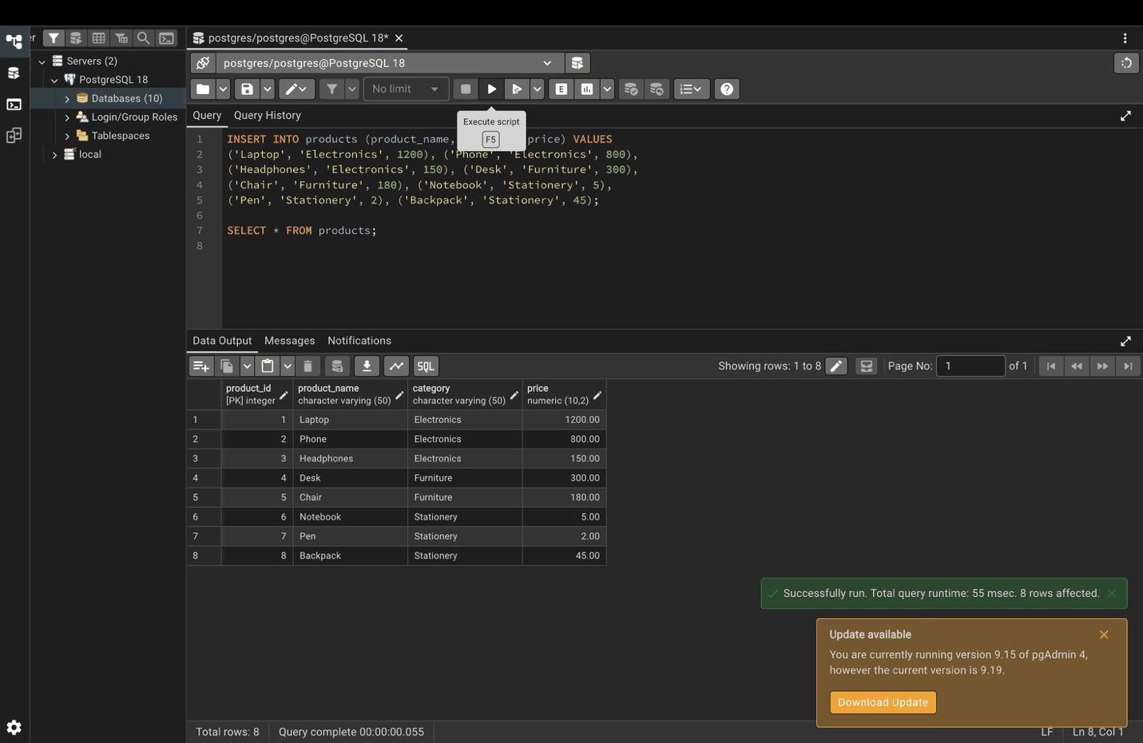

Part 2. Common aggregate functions

Step 5. COUNT
SELECT
COUNT(*) AS total_employees,
COUNT(email) AS employees_with_email,
COUNT(DISTINCT department) AS unique_departments
FROM employees;
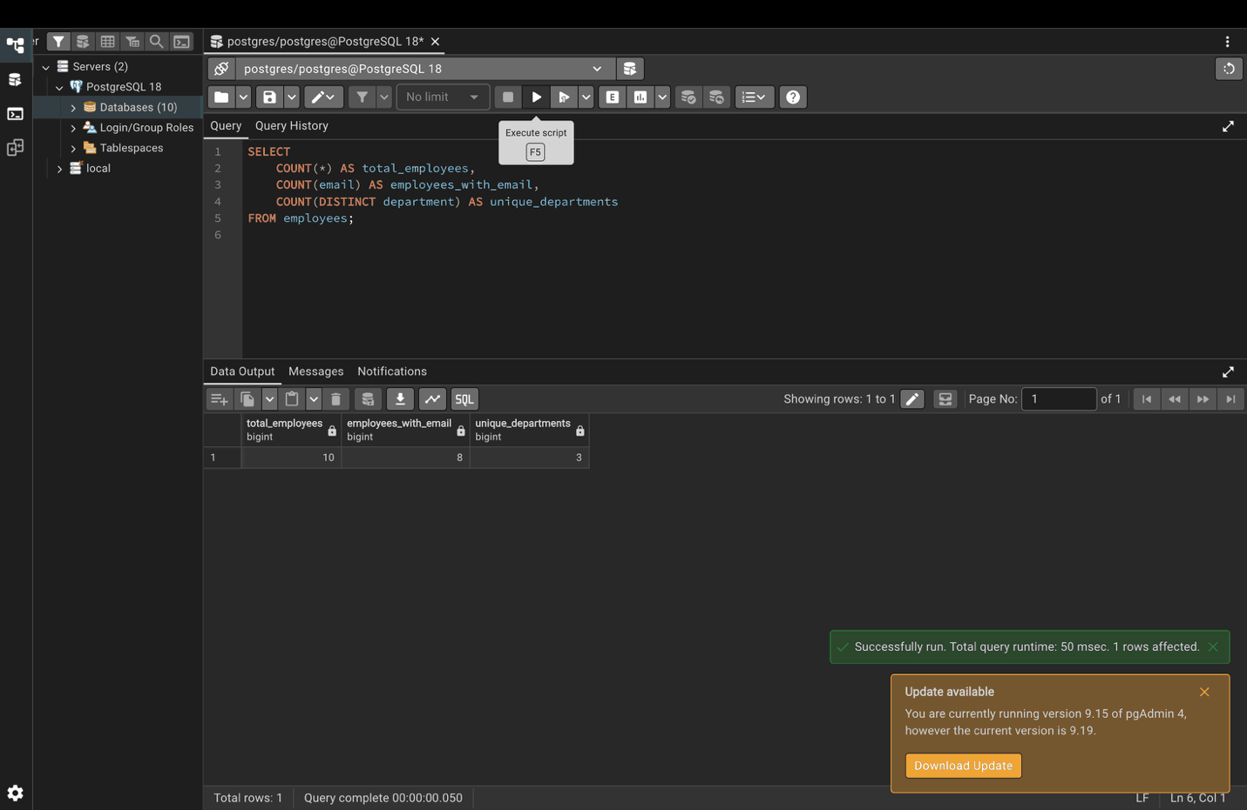

Step 6. SUM: total salary expenditure
SELECT SUM(salary) AS total_salaries
FROM employees;
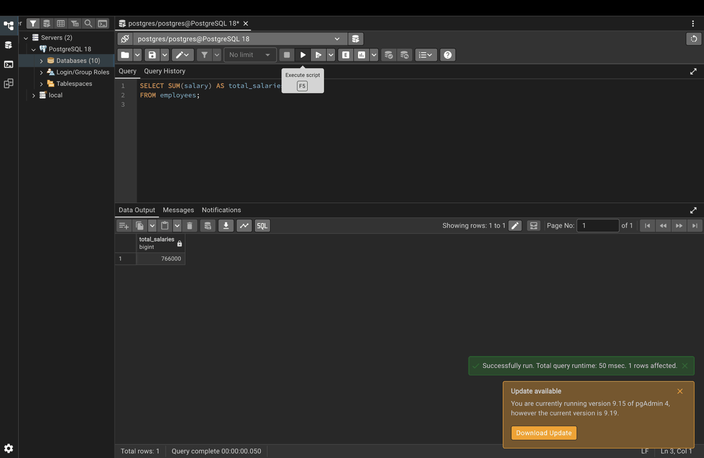

Step 7. SUM by department
SELECT department, SUM(salary) AS total_salaries
FROM employees
GROUP BY department;
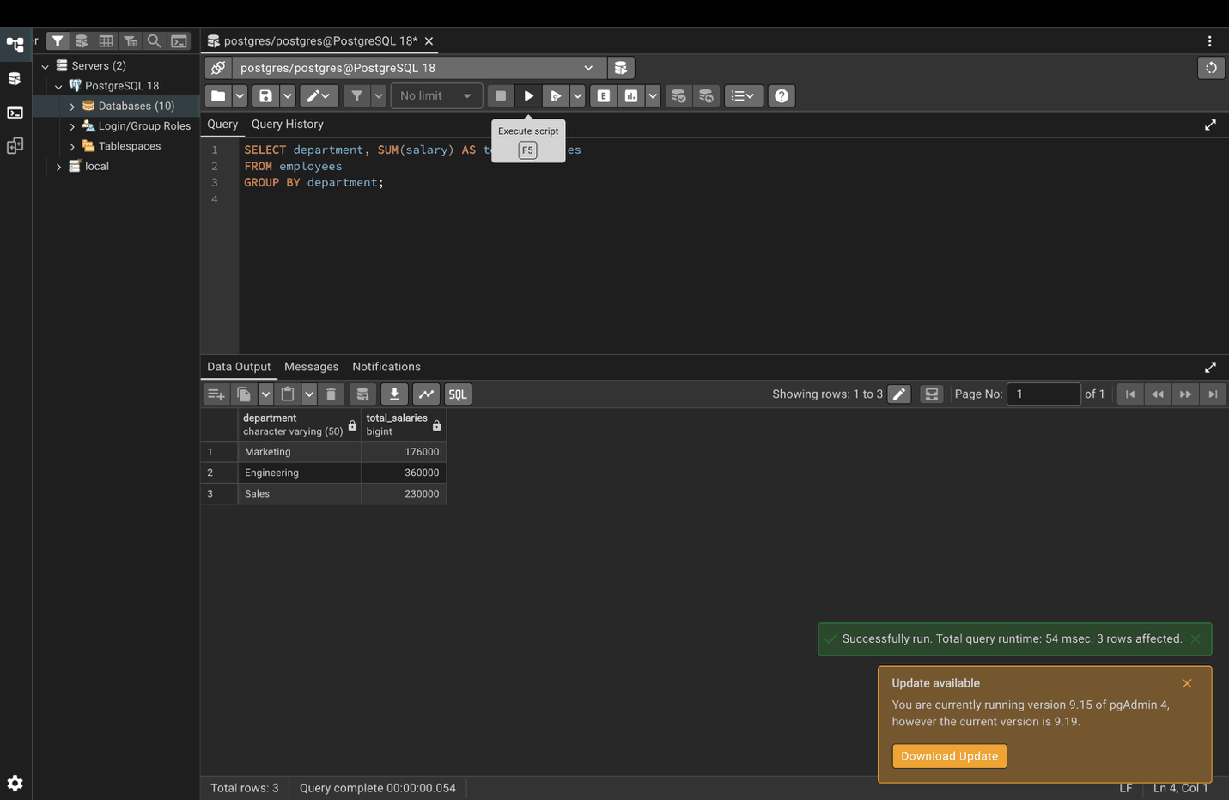

Step 8. AVG: average salary
SELECT AVG(salary) AS average_salary
FROM employees;
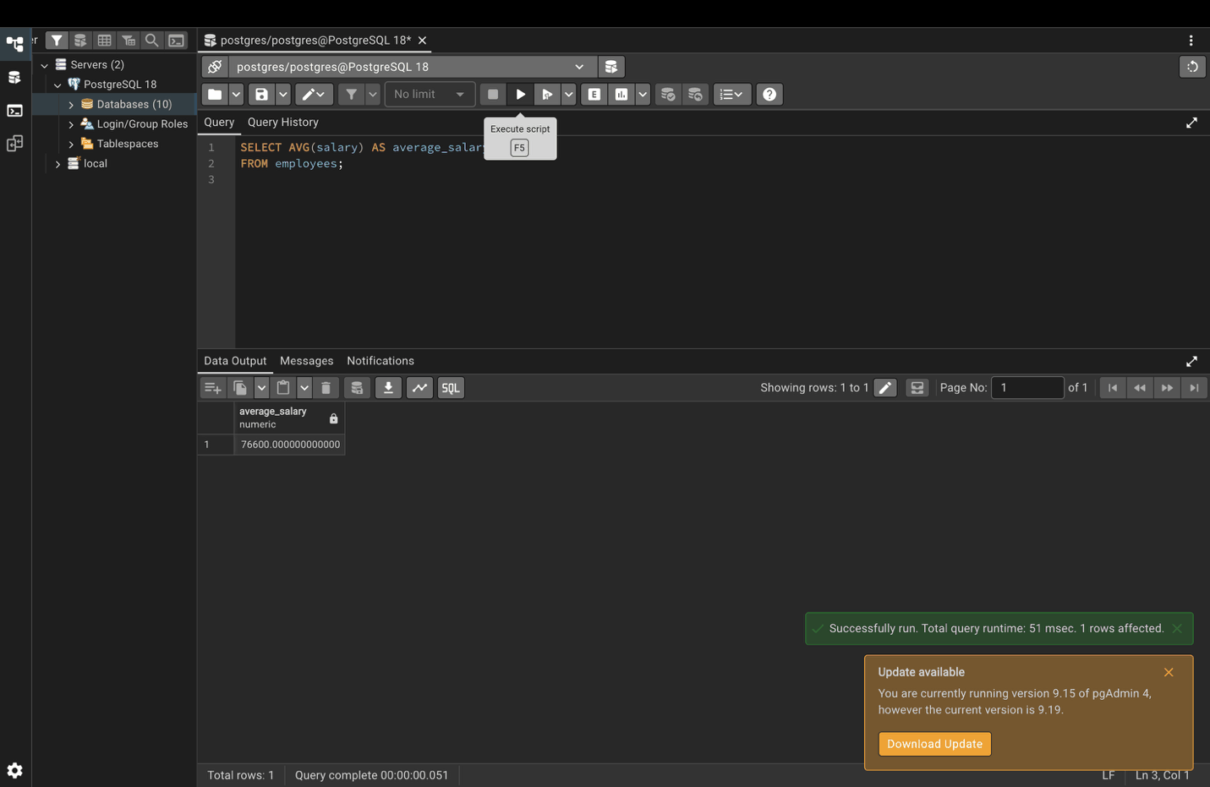

Step 9. AVG by department
SELECT department, AVG(age) AS avg_age
FROM employees
GROUP BY department;
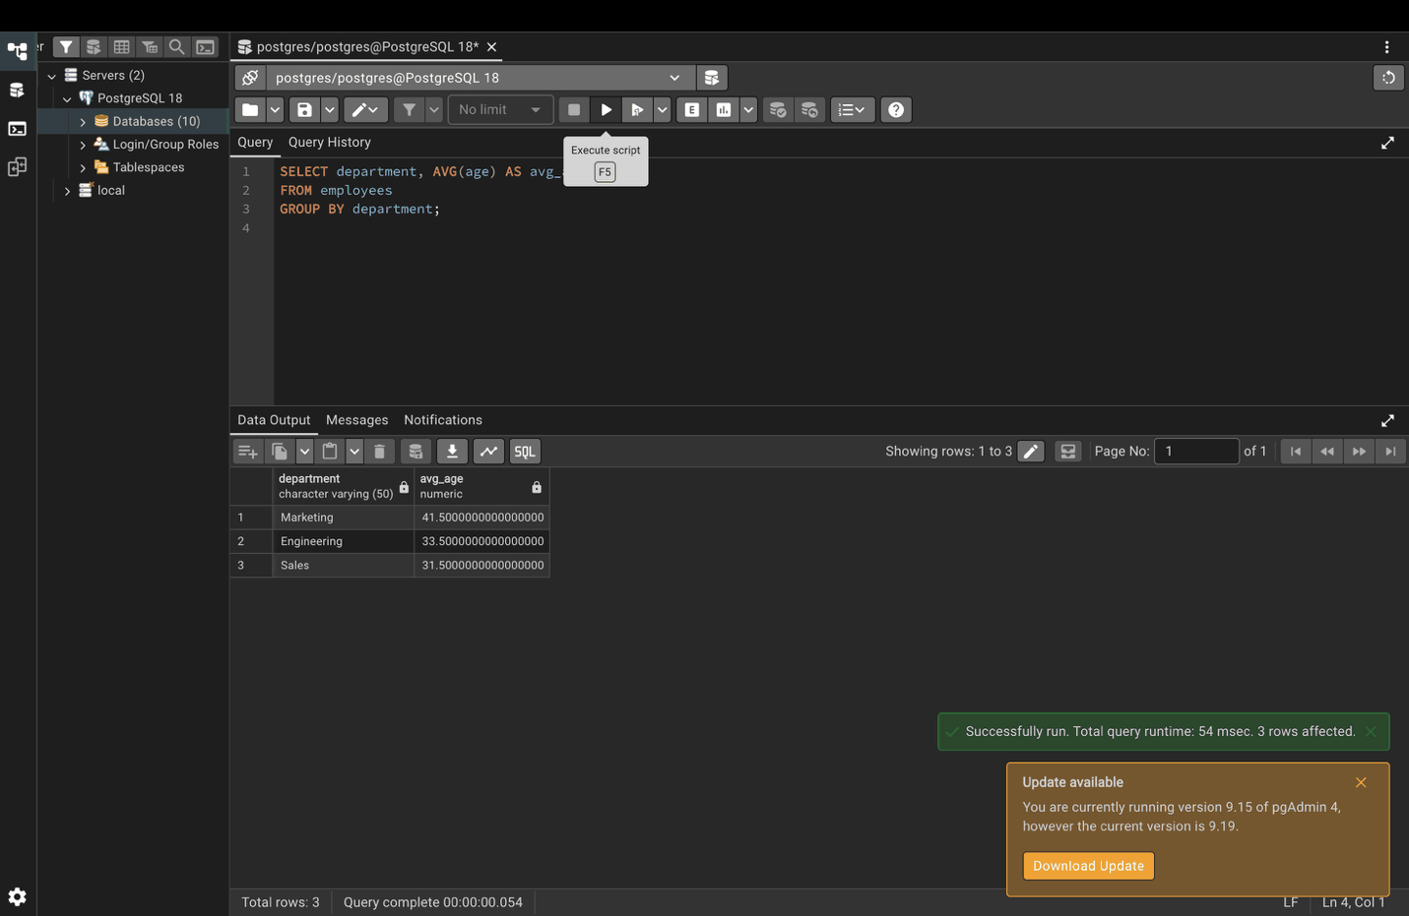

Step 10. MAX and MIN
SELECT
MAX(salary) AS highest_salary,
MIN(salary) AS lowest_salary
FROM employees;
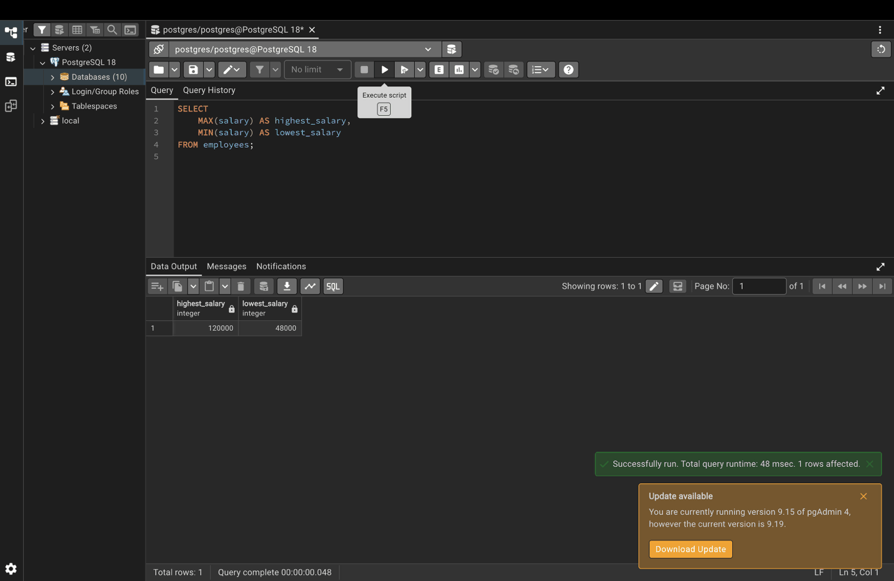

Step 11. Most recent hire by department
SELECT department, MAX(hire_date) AS latest_hire
FROM employees
GROUP BY department;
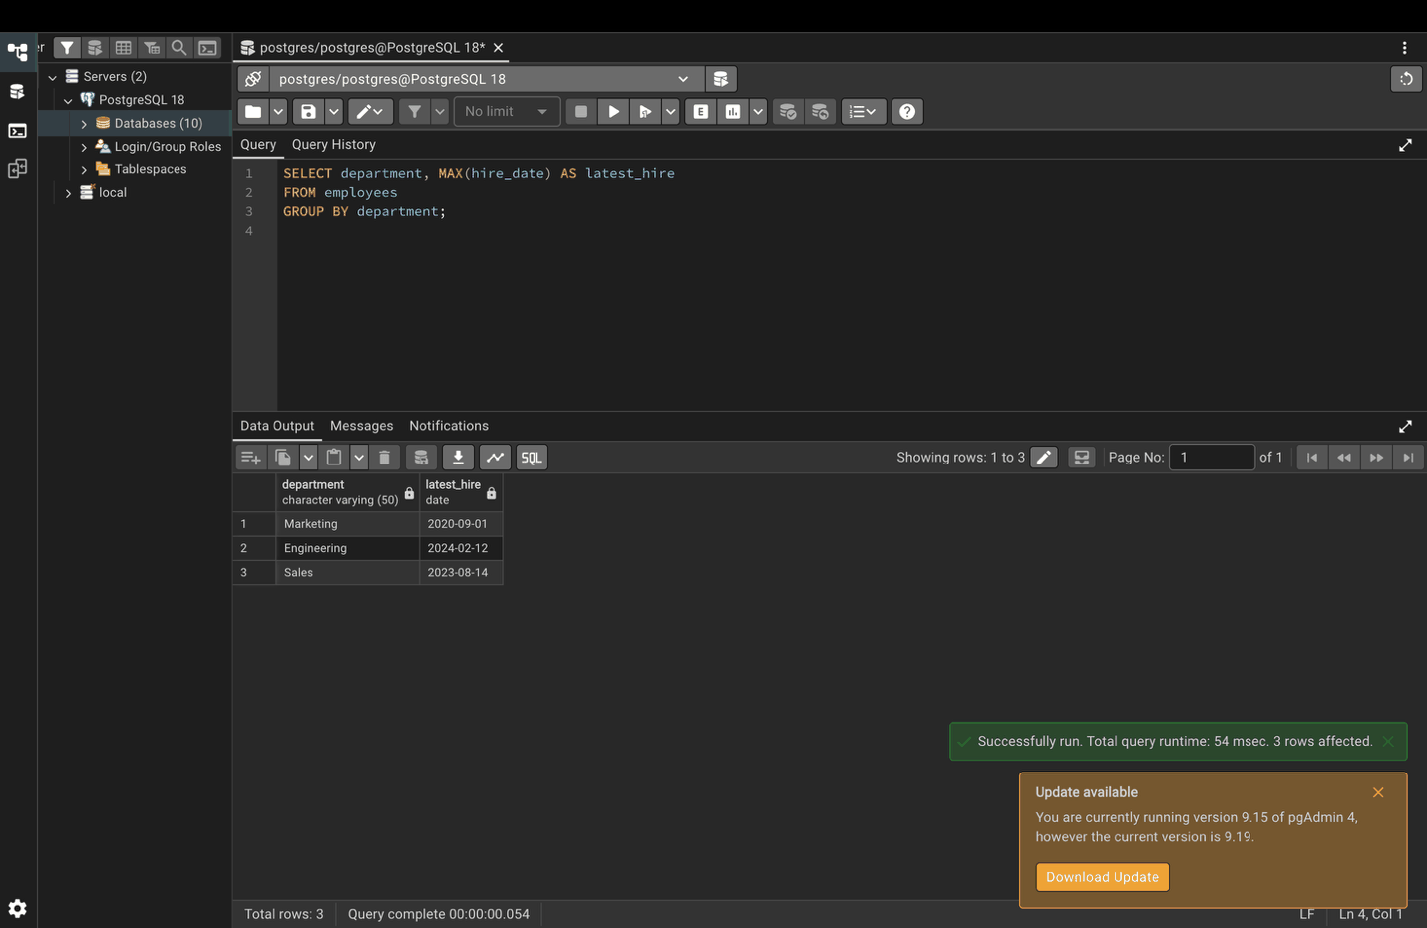

Part 3. Advanced aggregate functions

Step 12. STRING_AGG
SELECT department, STRING_AGG(first_name, ', ' ORDER BY first_name) AS employee_names
FROM employees
GROUP BY department;
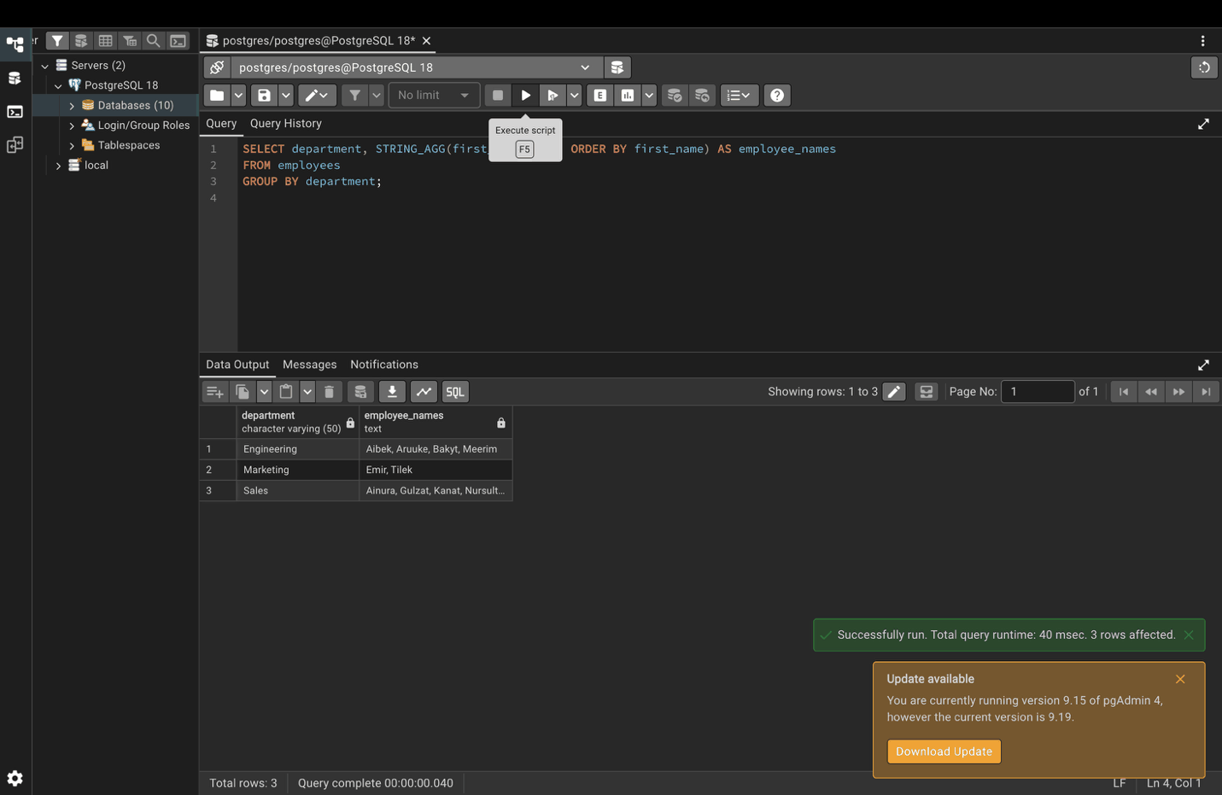

Step 13. ARRAY_AGG
SELECT department, ARRAY_AGG(salary ORDER BY salary) AS salary_array
FROM employees
GROUP BY department;
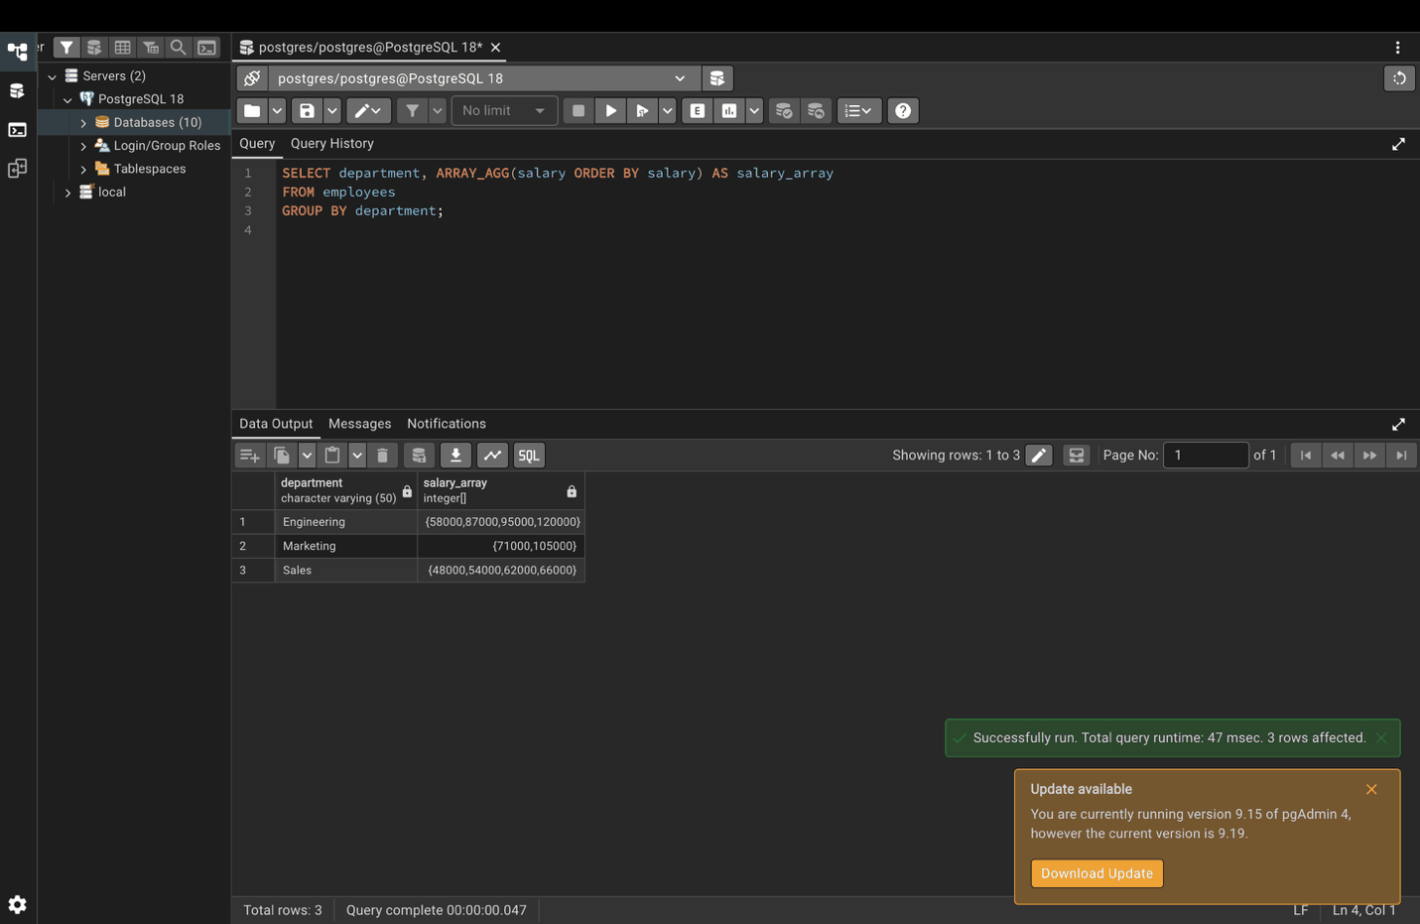

Step 14. STDDEV and VARIANCE
SELECT
department,
STDDEV(salary) AS salary_std_dev,
VARIANCE(salary) AS salary_variance
FROM employees
GROUP BY department;
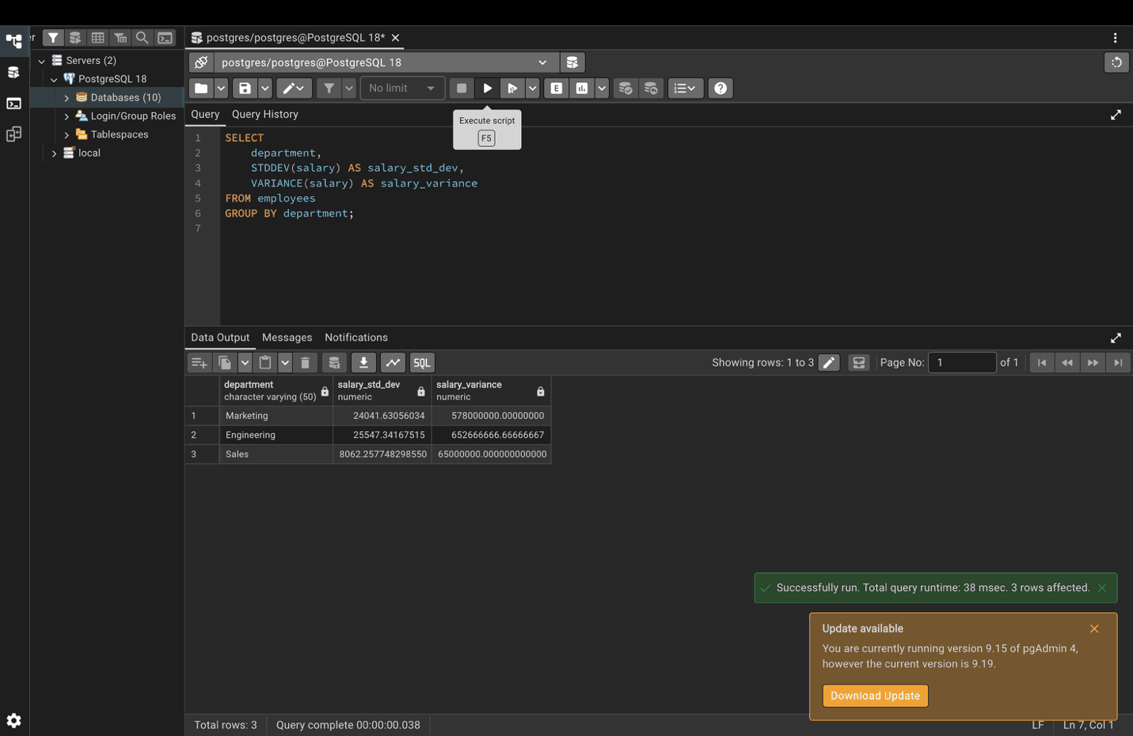

Step 15. CORR
A value close to 1 means more experience goes with a higher salary.
SELECT CORR(experience_years, salary) AS experience_salary_correlation
FROM employees;
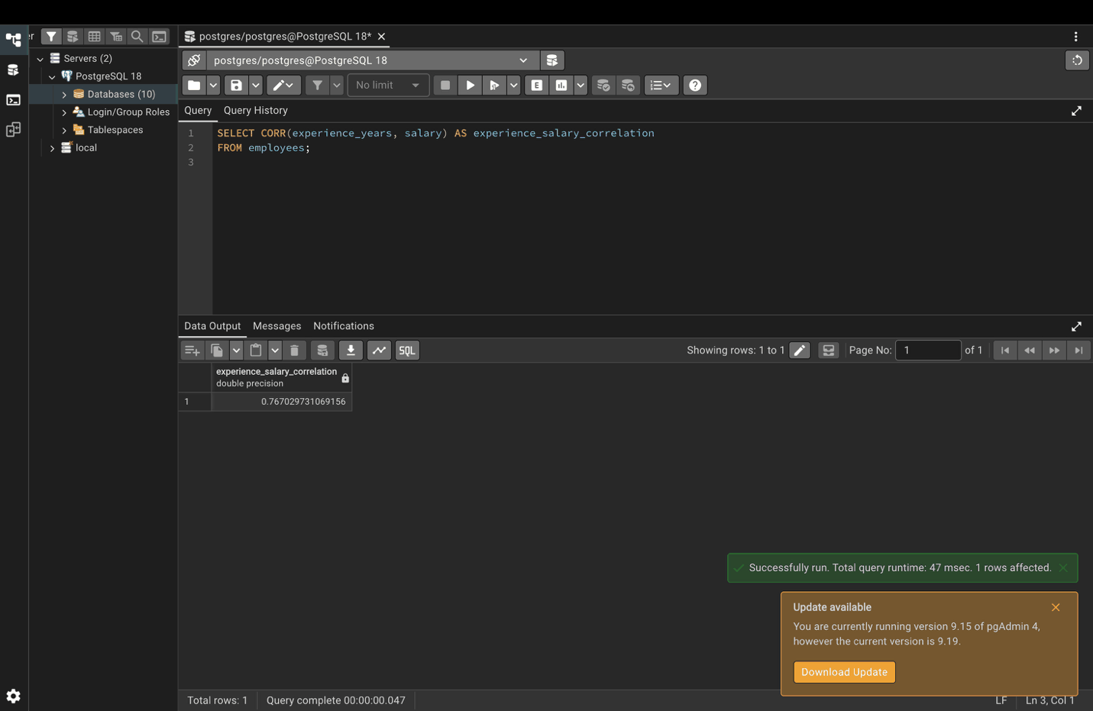

Part 4. GROUP BY

Step 16. Basic GROUP BY
SELECT
category,
COUNT(*) AS number_of_products,
SUM(price) AS total_value,
AVG(price) AS average_price
FROM products
GROUP BY category;
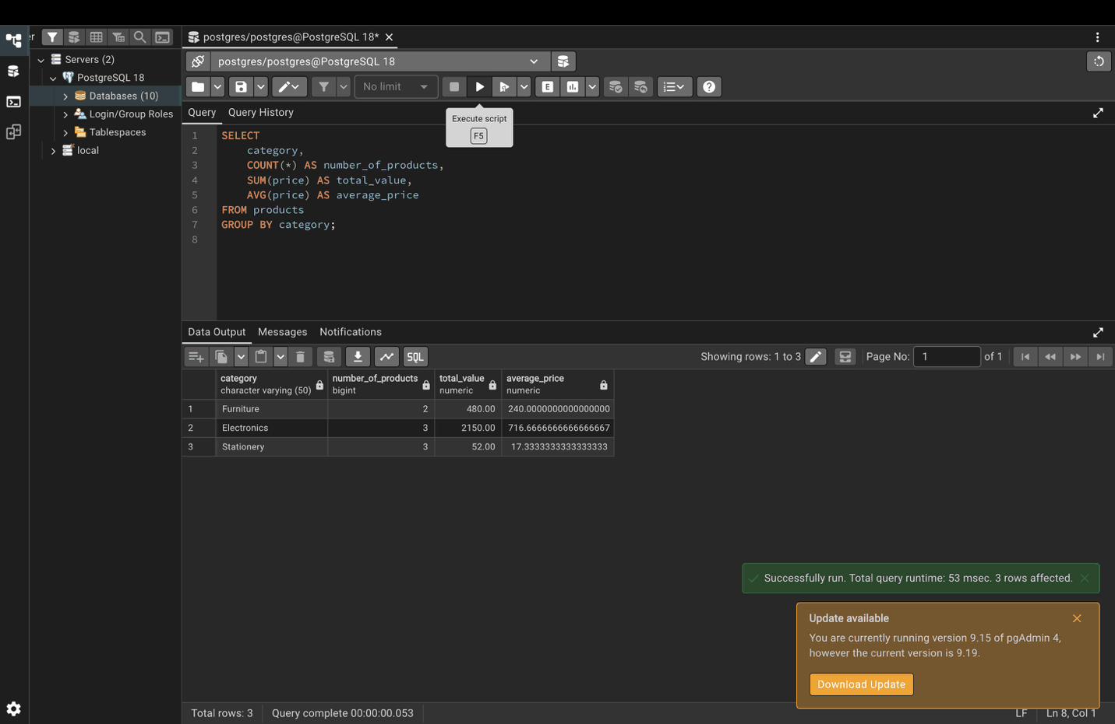

Step 17. Group by several columns (year and quarter)
SELECT
EXTRACT(YEAR FROM sale_date) AS year,
EXTRACT(QUARTER FROM sale_date) AS quarter,
COUNT(*) AS total_sales,
SUM(amount) AS total_revenue
FROM sales
GROUP BY EXTRACT(YEAR FROM sale_date), EXTRACT(QUARTER FROM sale_date)
ORDER BY year, quarter;
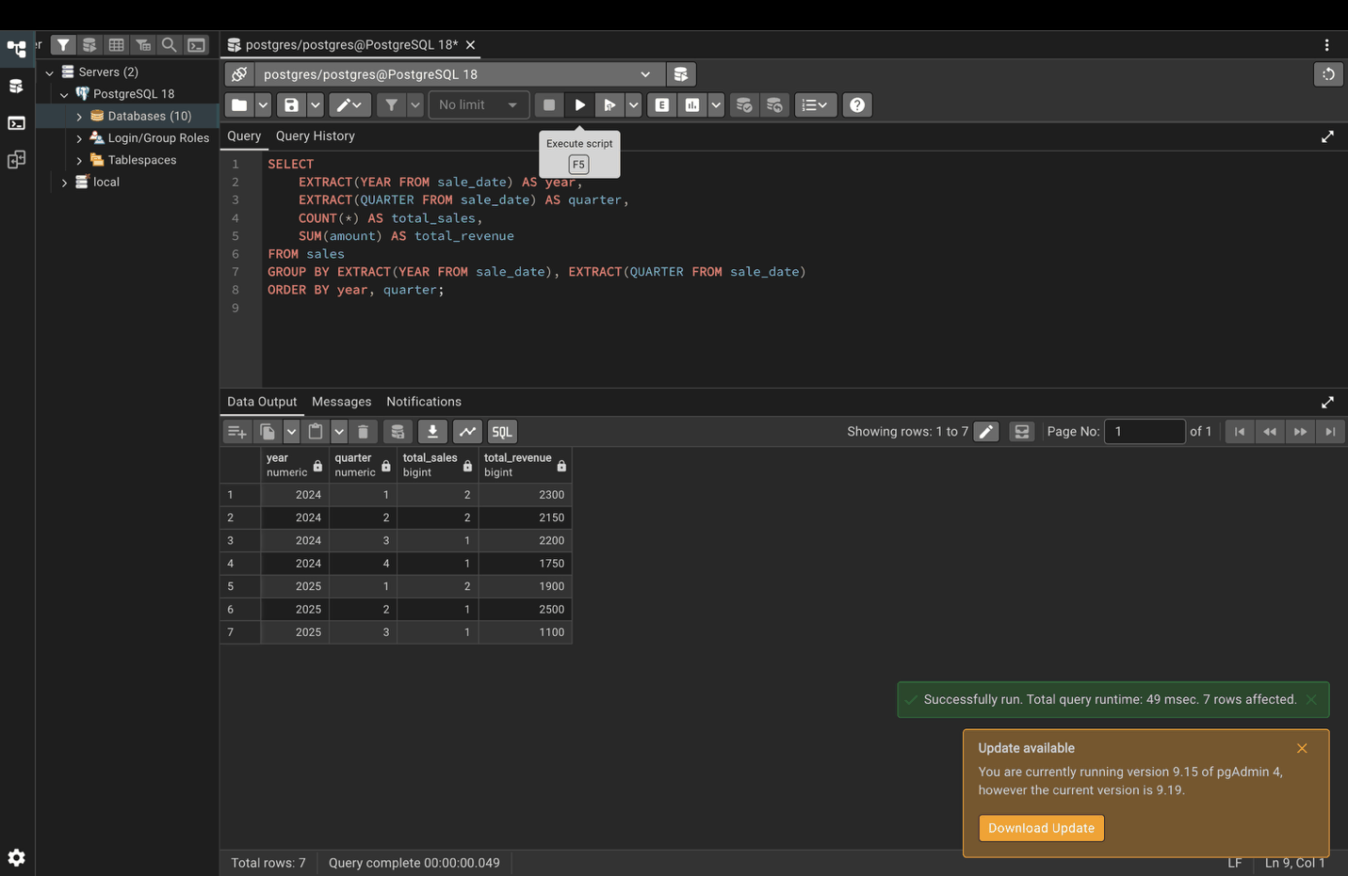

Step 18. Group by an expression (age groups)
SELECT
CASE
WHEN age < 30 THEN 'Under 30'
WHEN age BETWEEN 30 AND 50 THEN '30-50'
ELSE 'Over 50'
END AS age_group,
COUNT(*) AS employee_count,
AVG(salary) AS avg_salary
FROM employees
GROUP BY
CASE
WHEN age < 30 THEN 'Under 30'
WHEN age BETWEEN 30 AND 50 THEN '30-50'
ELSE 'Over 50'
END;
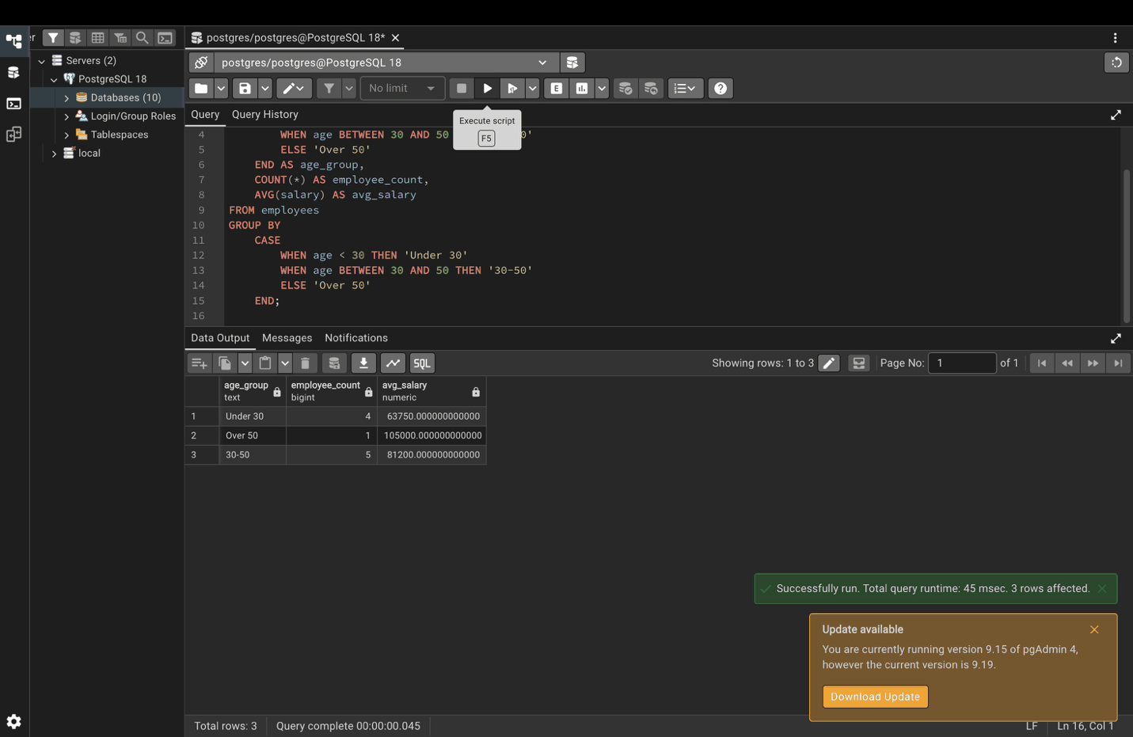

Part 5. HAVING

Step 19. Departments with more than 3 employees
WHERE filters rows before grouping; HAVING filters groups after grouping.
SELECT
department,
COUNT(*) AS employee_count
FROM employees
GROUP BY department
HAVING COUNT(*) > 3;
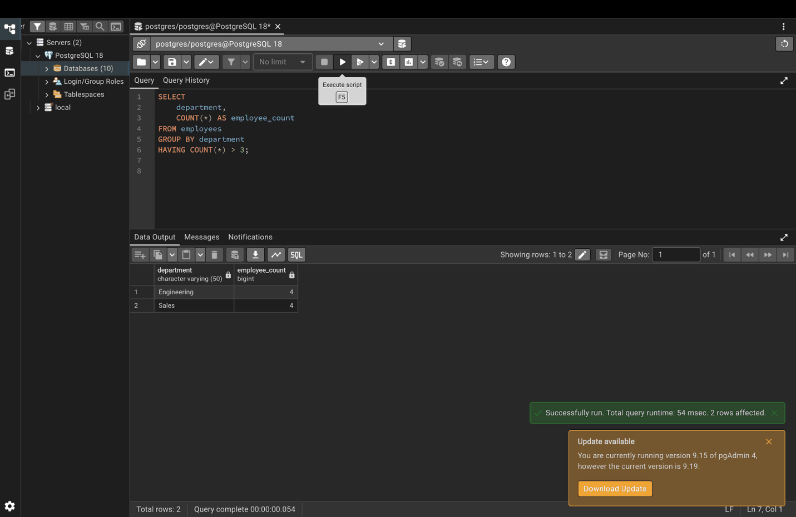

Part 6. Window functions vs aggregate functions

Step 20. Window function: department average on every row
GROUP BY returns one row per department; a window function keeps all 10 rows.
SELECT
employee_id,
first_name,
department,
salary,
AVG(salary) OVER (PARTITION BY department) AS dept_avg_salary
FROM employees;
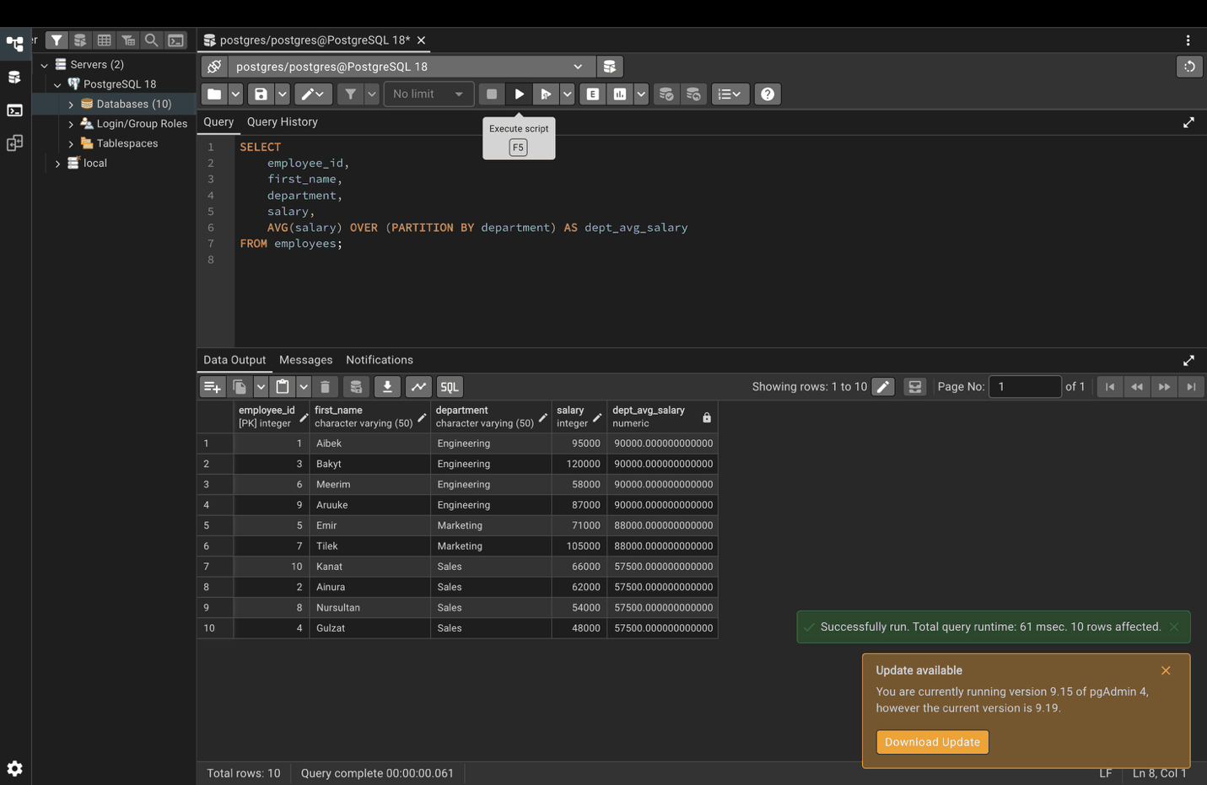

Part 7. Handling NULL values

Step 21. COUNT(*) vs COUNT(column)
SELECT
COUNT(*) AS total_rows,
COUNT(email) AS non_null_emails,
COUNT(*) - COUNT(email) AS null_emails
FROM employees;
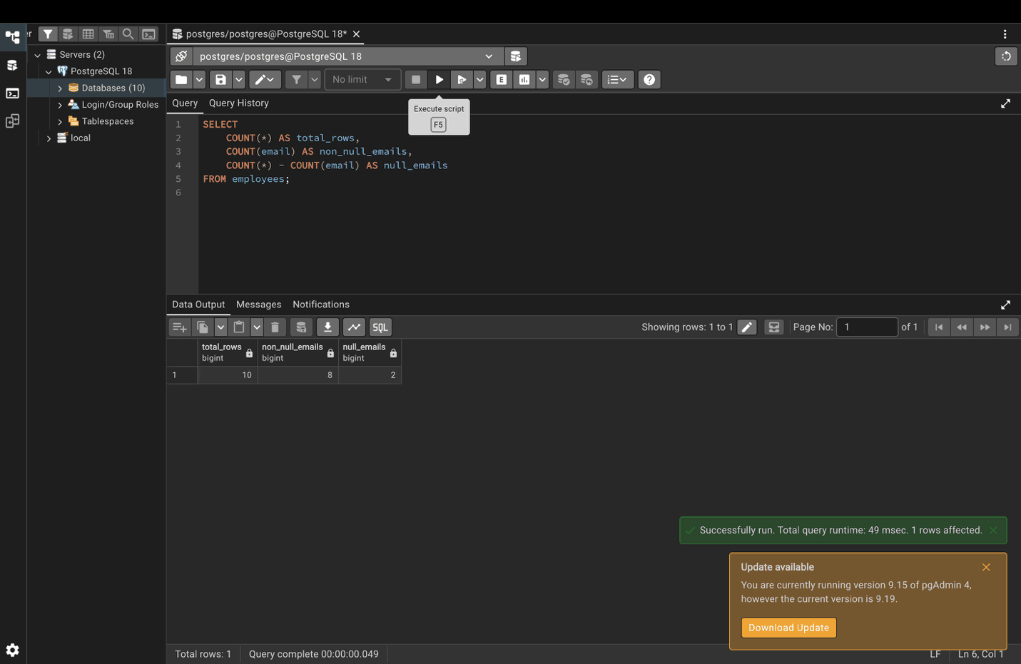

Step 22. SUM and AVG ignore NULLs
AVG divides by the 7 employees who have a bonus, not by all 10.
SELECT
SUM(bonus) AS total_bonus,
AVG(bonus) AS avg_bonus,
COUNT(bonus) AS employees_with_bonus
FROM employees;
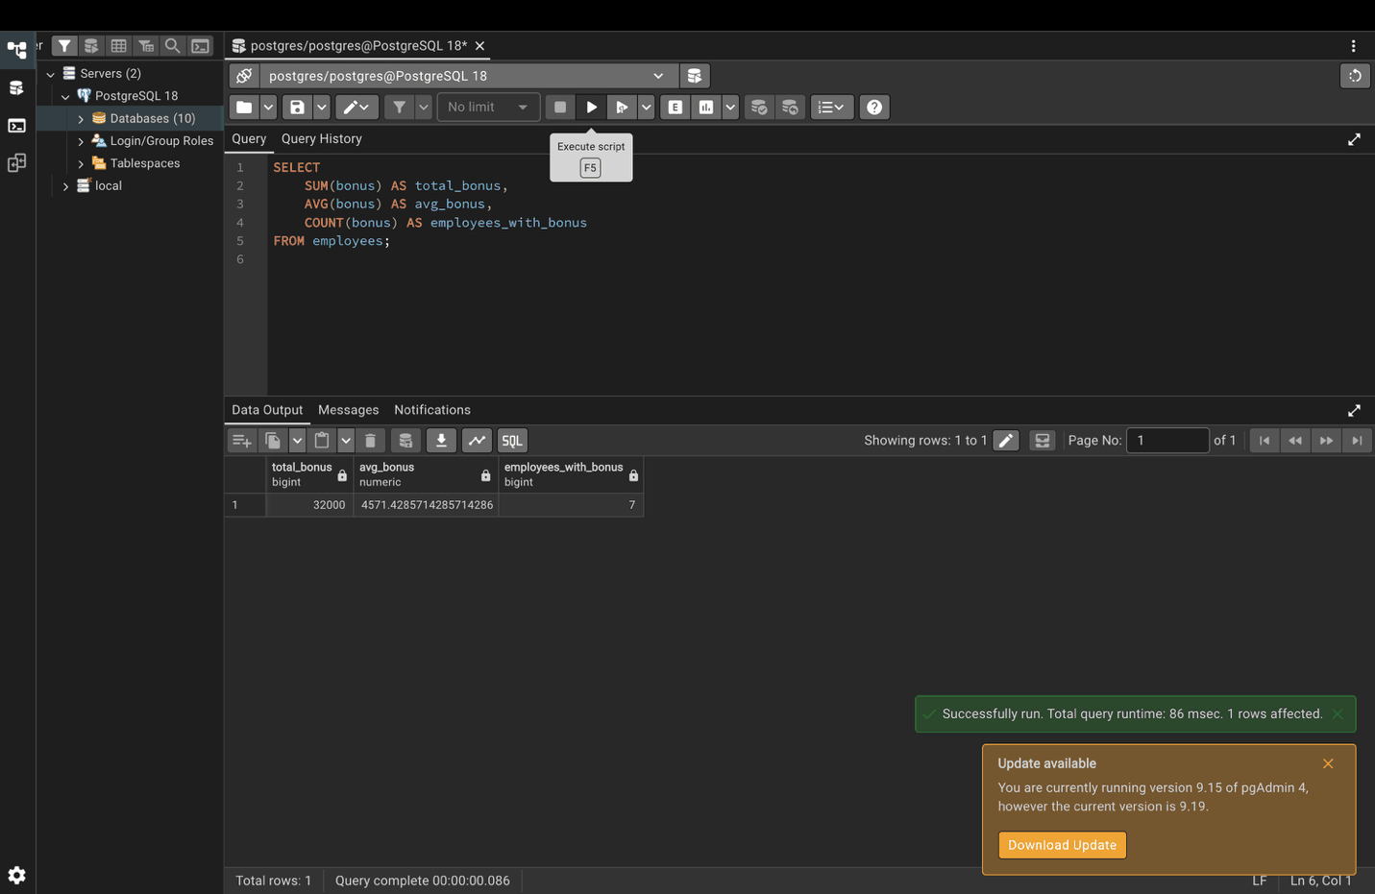

Part 8. Common patterns

Step 23. Combining multiple aggregations
SELECT
department,
COUNT(*) AS employee_count,
MIN(salary) AS min_salary,
MAX(salary) AS max_salary,
AVG(salary) AS avg_salary,
STDDEV(salary) AS salary_std_dev
FROM employees
GROUP BY department
ORDER BY avg_salary DESC;
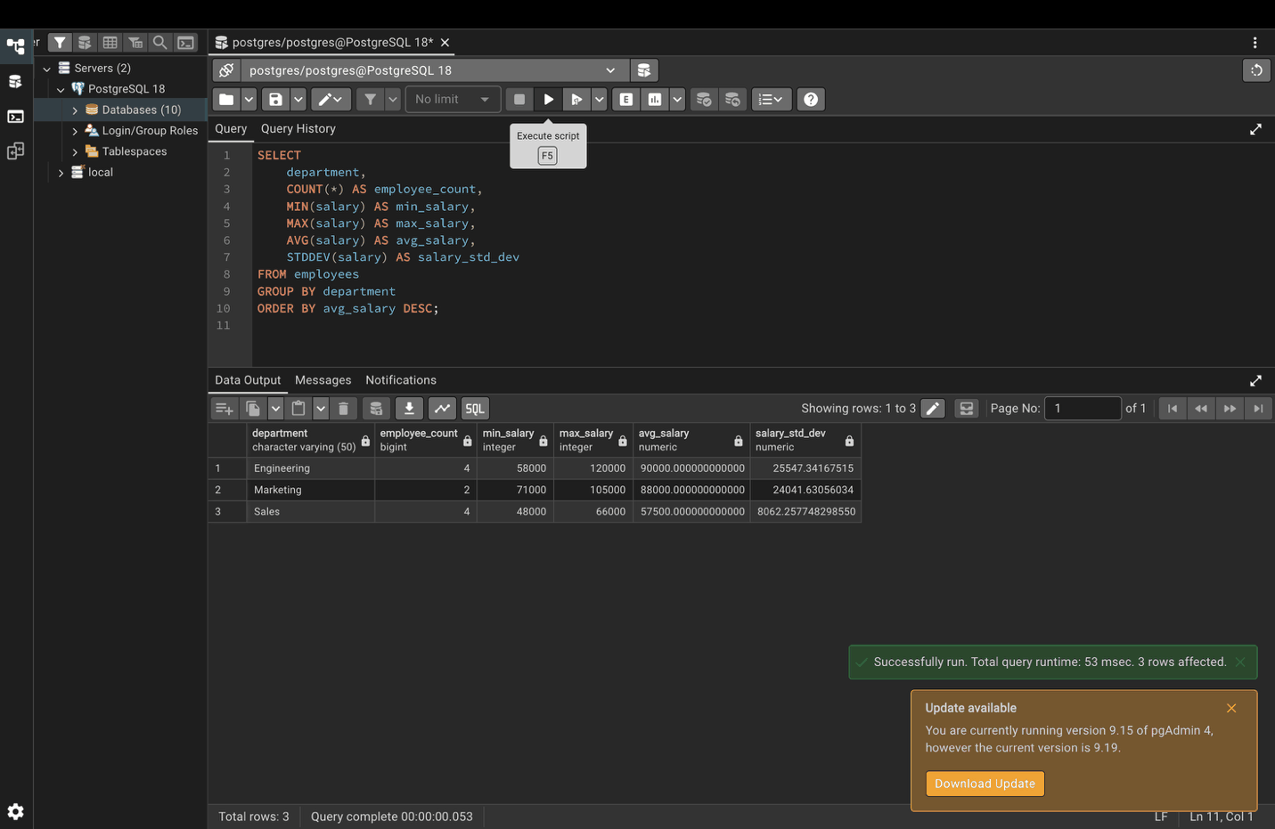

Step 24. Conditional aggregation
SELECT
department,
COUNT(*) AS total_employees,
COUNT(CASE WHEN salary > 60000 THEN 1 END) AS high_earners,
COUNT(CASE WHEN hire_date > '2023-01-01' THEN 1 END) AS recent_hires
FROM employees
GROUP BY department;
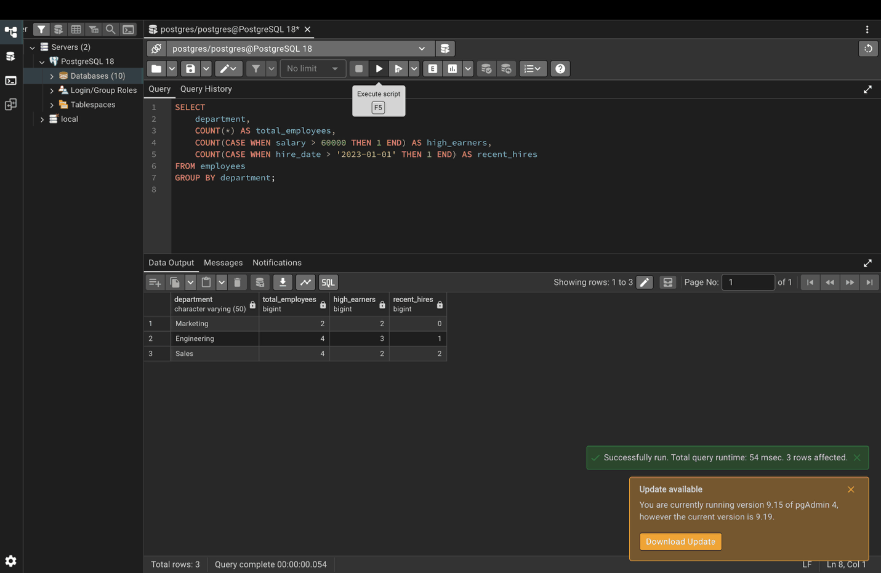

Step 25. Percentage of total
SELECT
department,
COUNT(*) AS dept_count,
COUNT(*)::FLOAT / (SELECT COUNT(*) FROM employees) * 100 AS percentage
FROM employees
GROUP BY department
ORDER BY percentage DESC;


